Steel mill touches off boom in Osceola
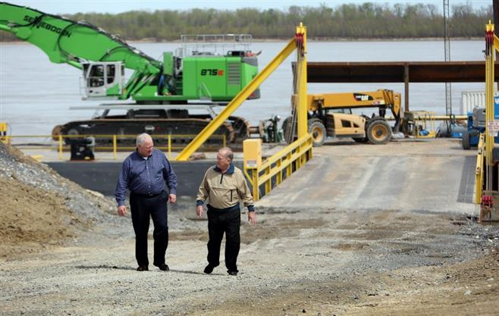
Stan Carroll/The Commercial Appeal April 1, 2016 - Osceola mayor Dickie Kennemore (right) and city finance manager Steve Purtee walk from a barge docked at the Mid-River Terminal located about 5 miles south of town and adjacent to Big River Steel.
Posted: April 02, 2016
April, and training classes are ramping up at Arkansas Northeastern College for workers such as welders and forklift drivers.
"I never dreamed in my wildest dreams we could ever attract something like this,'' Osceola Mayor Dickie Kennemore said. "If you want a job in Mississippi County today all you have to do is show up for work.''
The arrival of 700 permanent jobs — steel mill wages start at $75,000 per year — is welcome in a small city that fretted even Walmart passed it by after the U.S. Air Force in 1992 closed the huge B-52 bomber base up the road near Blytheville.
After the 3,000 military personnel moved away and a series of factories moved offshore, including the Fruit of the Loom plant, Osceola and surrounding Mississippi County struggled with double-digit unemployment rates through two decades.
Kennemore said the drop in the local jobless rate — it fell to 7.6 percent in January from 11.8 percent in 2010 — reflects more than the recession finally easing.
"It's not just recovering from the recession,'' said Kennemore, whose city contains only about 7,300 residents today, about 1,500 fewer than in 2000. "We're looking at about a $1 million increase in sales taxes over two years. That's indicative of the commerce that has increased in our community."
In 2013, the 1-cent sales tax contributed $750,000 to the city budget, then about $950,000 in 2014 and $1.3 million in 2015. The rise in sales taxes does not lead to lower property taxes — the state sets the millage in Arkansas.
"I'd say we're in a boom,'' Kennemore said, pointing out a local supermarket reports a 60-perecent rise in annual sales. "I guess maybe it's unbelievable because we had a large industrial base in the 1990s and we lost it. We had all these plants that moved the work offshore. When the rest of the country was in a boom we were in a depression.''
A sign the economic siege has lifted came recently when Arkansas Northeastern College in Blytheville announced it had received $180,000 in grants for schooling material handlers such as forklift drivers. This provides free training for low-income residents.
Those occupations are in demand at Mid-River Terminal, a new Osceola vendor to the steel mill. It unloads scrap from Mississippi River barges and delivers the metal to Big River, which melts it into molten steel shaped into coils for automotive, appliance and other manufacturers.
Last year, Mid-River disclosed its new $40 million plant would employ 130 workers. Other new suppliers include Arkansas Steel Processing's $35 million plant, which will create about 50 jobs, and SMS Millcraft's $30 million investment, which will create about 70 jobs.
Kennemore credits local officials with helping attract Big River. After Eaker Air Force Base closed and Fruit of the Loom left, the county enacted an economic development tax. When Big River came calling, the city pitched in $15 million in incentives, the county $2 million and the state eventually $125 million, making it the largest incentive package ever in Arkansas.
"As far as I'm concerned," Osceola Mayor Dickie Kennemore said, "we won the industrial lottery for any town in the U.S., particularly small-town America."

