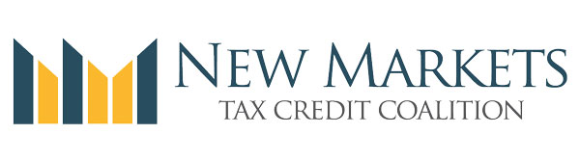

55 Members of Congress Sign Letter in Support of NMTC
This week 55 members of Congress signed a letter to House Ways and Means Chairman Kevin Brady (R-TX) urging him to include the NMTC in any tax reform legislation. The Coalition worked with Congressmen Steve Stivers (R-OH), Jose Serrano (D-NY), and Mike Turner (R-OH) on the sign-on letter to Chairman Brad. This is particularly timely as the House began holding hearings last week on Members ideas for tax legislation. As you know, Speaker of the House Paul Ryan (R-WI) created of six committee-led task forces earlier this year, which are charged with "developing a bold, pro-growth agenda that will be presented to the country in the months ahead." House Ways and Means Chairman Kevin Brady leads the Tax Reform Task Force, which has been directed to craft a tax reform proposal to "create jobs, grow the economy, and raise wages by reducing rates, removing special interest carve-outs, and making our broken tax code simpler and fairer." The task force's report is expected to be released in June. This letter, which signals solid bipartisan support for the NMTC, helps strengthen our request that New Markets Tax Credit is included as part of any tax reform proposal that emerges from the task force.
- View letter with signatures

May 27th Legislative Update Canceled
As the NMTC Coalition will be holding its conference next week and a full legislative update will be provided, the legislative update that would have taken place on Friday, May 27th is canceled. The next call will take place on June 24th at 3pm ET. As a reminder, we do not send Outlook notices anymore due to the size of the group, and ask that you please mark your calendar accordingly.

Register Now and Join us on June 1st for the 2016 NMTC Coalition Policy Conference
The 2016 NMTC Coalition's Policy Conference will be held next week on Wednesday, June 1st, from 8:30 am until 4 pm in Washington, DC. This year’s event will take place at the Hotel Palomar located at 2121 P Street Northwest. CDFI Fund Director Annie Donovan is confirmed as a keynote speaker. In addition, the Coalition will release its new 2016 NMTC Progress Report.
- Register Now!
As in past years, the NMTC Policy Conference will feature a great line-up of panels and informative speakers. Attendees will engage with senior Treasury and CDFI Fund staff, in addition to hearing from panels featuring NMTC industry leaders and experts on NMTC and the law. This year, the conference will also include a session on how CDEs and investors can engage the media to showcase their NMTC work, promoting their success to Congress and the community, which has even resulted in new business opportunities for some CDEs. The Coalition's public relations firm will offer best practices and Board Members who have worked with them will present on their experiences. The agenda will close out with an investor roundtable. Leading NMTC investors will discuss current and emerging trends and recent changes to the NMTC.
The agenda outline is posted on the Coalition website at http://nmtccoalition.org/events/

