CDFI Fund Releases Data for 2014 NMTC Transactions
Today, the CDFI Fund released data on NMTC transactions in 2014. The Fund included both a summary report and a spreadsheet, which includes all transactions between 2003 and 2014.
- CDFI Fund news release
- Summary Report
- Spreadsheet
The report shows that the NMTC continues to be targeted to areas that need it most:
-3,326 (73.2 percent) projects in the amount of $28,368,182,428 (73.7 percent), were located in census tracts that met one of the three indicators of “severe distress.”
-1,117 (24.6 percent) projects, in the amount of $9,592,229,959 (24.9 percent), were located in census tracts that met all three indicators of “severe distress.”
Underserved States:
We analyzed the transaction data to see which states saw an upsurge in investment in 2014, and which lagged behind. The map below shows that Nevada, Idaho, Montana, Arkansas, and Nebraska saw an uptick in NMTC loans and investments in 2014 compared to the historic average.
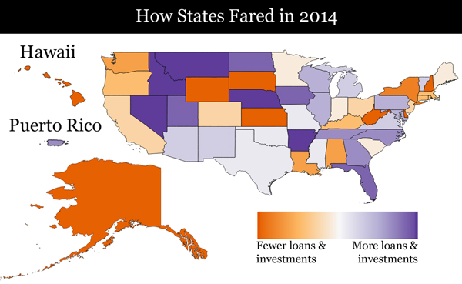
We plan to analyze the data and will have more soon.

Secretary Clinton Touts the NMTC in her Economic Speech
Today, Secretary Clinton mentioned the NMTC in a speech laying our her economic agenda. The link below will take you to the spot where she mentions the NMTC.
- Watch the video
Transcript:
"Let's also expand incentives like the New Market Tax Credit that can bring businesses, government, and communities together to create good jobs in places that will be left out and left behind - from neglected neighborhoods in Detroit, to logging country, coal country, Native American communities, rural areas, ravaged by addiction and lost jobs, to regions where factories close."

2016 NMTC Coalition Annual Conference Registration Open
Today, the Coalition opened registration for its 2016 Annual Conference, which will be held on December 14 and 15 in Washington, D.C. at the Hotel Monaco. Register now to take advantage of special early bird rates.
- REGISTER NOW!
Unsubscribe from this list
