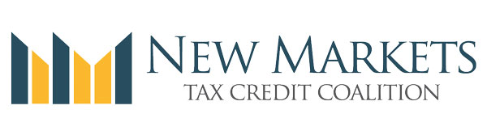

New Philly Page on Coalition Website Highlights the Impact of the NMTC
Today, the Democratic National Convention begins in Philadelphia, PA. As we did with Cleveland, the NMTC Coalition has setup a special page on our website highlighting the impact of the program in Philly:
- The NMTC in Philadelphia
The page includes videos, pictures, project profiles, and stats. We encourage you to share the site on social media, and we plan to add more projects, pictures, and stories as the week unfolds. In particular, we ask you to tweet Philadelphia NMTC stories using the hashtags #NMTC and #DemsInPhilly.
If you have additional content you would like to be featured on the Philadelphia, please send it to Paul Anderson paul@rapoza.org.

Webinar: In-District Advocacy and Legislative Update
Join us for a webinar tomorrow, July 26, 2016 at 3:00 PM ET. The purpose of this webinar is to provide a legislative update to NMTC Coalition members and walk through an in-district advocacy toolkit created to assist with outreach to Members of Congress during their seven week summer recess.
Register now!
https://attendee.gotowebinar.com/register/4657255653780851457
After registering, you will receive a confirmation email containing information about joining the webinar. Be sure to view System Requirements in advance. Thank you for your attention and we look forward to having you all participate tomorrow.
Unsubscribe from this list
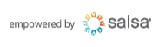

New Cleveland Page on Coalition Website Highlights the Impact of the NMTC
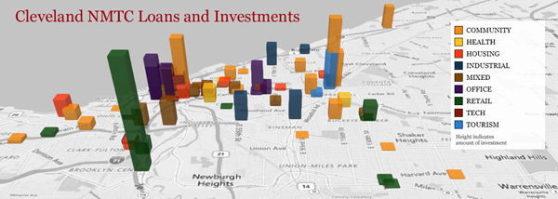
Next week, Republicans gather in Cleveland for their presidential convention. In advance of next week's events, the Coalition has setup a special page on our website highlighting the impact of the program in Cleveland:
- The NMTC in Cleveland
The page includes videos, pictures, project profiles, maps, and quotes from key Republican NMTC supporters. We encourage you to share the site on social media, and we plan to add more projects, pictures, and stories as the week unfolds. In particular, we ask you to tweet Cleveland NMTC stories using the hashtags #NMTC and #CLE2016.
Late next week, we will launch a similar site for Philadelphia in anticipation of the Democratic Convention. If you have content you would like to be featured on the Philadelphia or Cleveland page, please send it to Paul Anderson paul@rapoza.org.

Webinar: In-District Advocacy and Legislative Update
Join us for a webinar on July 26, 2016 at 3:00 PM ET. The purpose of this webinar is to provide a legislative update to NMTC Coalition members and walk through an in-district advocacy toolkit created to assist with outreach to Members of Congress during their seven week summer recess.
Register now!
https://attendee.gotowebinar.com/register/4657255653780851457
After registering, you will receive a confirmation email containing information about joining the webinar. Be sure to view System Requirements in advance. Thank you for your attention and we look forward to having you all participate on July 26th.
Unsubscribe from this list

