NMTC Program QEI Issuance Thresholds for CY 2017
Today the CDFI Fund put out a notice on the release of QEI issuance thresholds for the 2017 NMTC Allocation Round. The minimum thresholds as announced by the Fund are listed below.
- CY 2011 Allocatees: 100% minimum QEI issuance for the CY 2011 Allocation awards as of 11:59 p.m. ET on July 20, 2017.
- CY 2012 Allocatees: 80% minimum QEI issuance for the CY 2012 Allocation awards as of 11:59 p.m. ET on July 20, 2017.
- CY 2013 Allocatees: 70% minimum QEI issuance for the CY 2013 Allocation awards as of 11:59 p.m. ET on July 20, 2017.
- CY 2014 Allocatees: 50% minimum QEI issuance for the CY 2014 Allocation awards as of 11:59 p.m. ET on July 20, 2017. Rural CDEs awarded in CY 2014 will be required to issue as QEIs a minimum of 30% of their CY 2014 allocations.
- CY 2015-2016 Allocatees: 30% minimum QEI issuance for the CY 2015-CY2016 Allocation awards as of 11:59 p.m. ET on July 20, 2017. Rural CDEs will not be required to issue a minimum amount of their CY 2015-2016 Allocation awards.
Allocatees from Multiple Rounds: Allocatees that have received multiple allocations between CY 2011 and CY 2015-2016 that do not meet the minimum threshold for a specific round can also meet the minimum QEI issuance requirements on a cumulative basis. A CDE that received multiple NMTC allocation awards between CY 2011 and CY 2015-2016, shall be deemed to have met the QEI issuance thresholds, if it has issued and finalized a minimum of 90% of their cumulative allocation amounts by 11:59 p.m. ET on July 20, 2017.
Rural CDEs that received allocations under the CY 2014 allocation round may choose to exclude such allocations from this cumulative calculation, provided that the Allocatee issued at least 20 percent of QEIs relating to its CY 2014 allocation as of 11:59 p.m. ET on July 20, 2017.
Rural CDEs that received allocations under the CY 2015-2016 allocation round may choose to exclude such allocation from this cumulative calculation.

Congressman Richard Neal Named As Ways and Means Ranking Member
Today, Rep. Richard Neal (D-MA) was selected as the top-ranked Democrat on the House Ways and Means Committee. Rep. Neal is a longtime champion of the New Markets Tax Credit and scheduled to speak at the upcoming NMTC Coalition Annual Conference in Washington, D.C. More details on the event are listed below, including details on how to register and attend.
Chairman Kevin Brady (R-TX) issued a statement on Rep. Neal's selection as Ranking Member. Read his statement.

Join us for the 2016 NMTC Coalition Annual Conference!
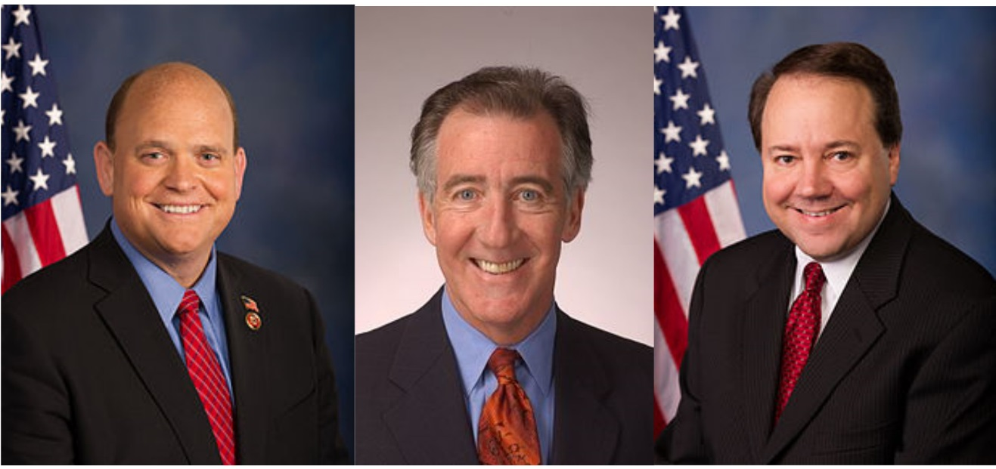
The 2016 NMTC Coalition Annual Conference will take place on December 14-15 at the Hotel Monaco in Washington, D.C. We have confirmed that Congressman Tom Reed (R-NY) will provide keynote remarks during the opening plenary, and Congressmen Richard E. Neal (D-MA) and Pat Tiberi (R-OH) will address attendees on December 15th. All are members of the Ways and Means Committee and lead sponsors of the New Markets Tax Credit Extension Act of 2015. Rep. Reed has just been named a Vice Chair of the Trump Transition Committee.
As you know, President-elect Trump and the Republican majorities in the House and Senate have made tax reform a priority and we expect that a major re-write of the Internal Revenue Code will be among the first items on the agenda of the new President and the 115th Congress. This means that we have a lot of work to do to ensure our congressional champions have the information they need to support the NMTC in the year ahead, as well as educate potential supporters on the impact the credit has had in their states and districts. Notwithstanding our success in securing a five-year, $17.5 billion extension of NMTC in the PATH in December of 2015, it is clear that we face a challenge in both maintaining the remaining three years of the PATH Act and continuing our campaign for a permanent extension.
This year's event will include time for attendees to visit their Members of Congress, as well as attend a Capitol Hill reception. The conference also provides one of the first opportunities for the NMTC industry to engage with the CDFI Fund after the 2015-2016 "super round," awarding CDEs $7 billion in NMTC allocations. In addition, attendees will learn and hear from key staff in Congress, Treasury as well as industry experts concerning policy and regulatory plans for the NMTC. The agenda can be found on the NMTC Coalition website on the "Events" page: http://nmtccoalition.org/events/
NMTC Coalition Member Rates: $450
Not a member yet? Join the NMTC Coalition today!
Non-Member Rates: $525

REGISTER NOW!

Notice: Annual Business Meeting and Membership Director Nominations
The Annual Business Meeting of the New Markets Tax Credit Coalition is scheduled for December 15, 2016 from 8:00 to 8:30 a.m. at Hotel Monaco in Washington, D.C. The Annual Meeting is open to all NMTC Coalition members.
As you know, the NMTC Coalition Membership has the opportunity to nominate and elect two Membership Directors to the Board each year. The election of the two Directors takes place at the Annual Membership Meeting. Please note, only current NMTC Coalition members in good standing can vote at the Coalitions Annual Meeting.
Unsubscribe from this list
