Phil Glynn – Phil’s job is to bring as much capital as possible to American Indian, Alaska Native and Native Hawaiian communities. These investments help change agents build new health care, education, infrastructure, housing and other developments in their communities. If you want to know specifically how Travois can help you structure your investments, attract capital, design buildings and manage your developments, contact Phil any time.

Travois sees value where other people don’t. They identify leaders in local communities who have a vision. They support those leaders as they build consensus around that vision. Once the community gets behind the idea, Travois provides the capital and technical assistance required to make it a reality. Then they bring in outside investors and show them what is already known already know — that when Indian Country communities come together, there is nothing they can’t accomplish.

After the deal has closed, the doors are open, and the celebration has quieted down, Travois remains right next to those local leaders, continuing on the journey helping that specific development to succeed while keeping an eye on the horizon for what comes next.

Every day in this job, Phil finds himself relying on the great education he was so blessed to receive. Phil uses his bachelor’s degree in English from Wake Forest University when writing for the Travois blog. He uses his master’s degree in public administration from the University of Missouri-Kansas City when working with various levels of tribal and federal government to move projects forward. And his executive certificate in negotiation from the Harvard Kennedy School of Government is beneficial every day when he tries to get his family fed, brushed, dressed, combed and off to school on time.

Then Phil settles into his desk at Travois and does what he loves to do: listen to Indian Country’s most dynamic community economic development professionals talk about their vision for the future, and work together to make it a reality.
2023 NMTC PROGRESS REPORT
 | Chris Huang - Chris Huang is Senior Director of Accion Opportunity Fund’s New Markets Tax Credits (NMTC) Program. In this role, he has led or supported the execution of NMTC transactions totaling $240 million in the western U.S., focused on financing the construction or rehabilitation of non-profit community facilities and Native American jobs projects that provide quality jobs and safety net services in low-income communities. He is responsible for sourcing, underwriting, leading loan closings, and overseeing asset management and compliance of a $231 million NMTC loan portfolio. He leads a team of 5 staff. Prior to Accion Opportunity Fund, Mr. Huang was Director of Operations at the New York City Mayor’s Office of Immigrant Affairs, where he was responsible for starting up a citywide immigration legal services program and managing its day-to-day finances and operations. Mr. Huang has also provided capacity building consulting services to social and economic justice non-profits and worked in policy advocacy. Mr. Huang serves on the board of directors of the Charities Housing Development Corporation, an affordable housing developer. He has an MBA from NYU Stern School of Business, specializing in Finance and Change Management, and a BA in Economics from the University of Chicago.
 | Jennifer Bransfield - A corporate attorney with an MBA and more than 20 years of experience, Jennifer’s responsibilities at CNI include operations, internal and programmatic legal, and finance; board, funder and government relations; and direction of the NMTC program. Jennifer previously served as counsel at a bank holding company and worked in the economic consulting and tax practices at international firms. Jennifer earned her undergraduate degree from the University of Southern California, her JD and MBA from Pepperdine and is a University of Chicago Civic Leadership Academy Fellow and is certified through Stanford University’s Executive Program for Nonprofit Leaders. She is also a member of University of Chicago’s Nonprofit Network for Strategic Finance and Operations and frequently speaks in classrooms. Jennifer also serves as a director on the boards of Christ the King Jesuit College Prep, New Markets Tax Credit Coalition and Friends of Big Marsh.
Eileen Fitzgerald - Eileen Fitzgerald is the founder and principal of ThruSight LLC, a strategic consulting and advisory services firm. As a principal at ThruSight, she leverages the expertise and insight she gained as a leader in her more than 30-year career in the housing, community development, and nonprofit industry.

Prior to forming ThruSight, Fitzgerald served as head of housing affordability philanthropy with Wells Fargo, where she led the development and execution of a $1 billion Housing Affordability Philanthropy commitment. At Wells Fargo, she initiated an immediate response to the COVID-19 pandemic with the Keeping People Housed initiative, and also launched the $60 million WORTH program to support 40,000 new homeowners of color. She spearheaded the $40 million Growing Diverse Housing Developers initiative to increase affordable housing supply and support the increased financial strength and capacity of Black and Latino developers.

Fitzgerald previously served as president and chief executive officer of Stewards of Affordable Housing for the Future (SAHF), a collaborative of nonprofits that collectively owns and operates more than 140,000 affordable rental homes nationwide with a focus on advancing the creation and preservation of healthy sustainable affordable rental homes for low- and moderate-income households. At SAHF, she also launched CORES (Certified Organization for Resident Services and Engagement) and played a key role in SAHF’s energy and climate work.

Fitzgerald also previously served as chief executive officer and chief operating officer with NeighborWorks® America. During her tenure, NeighborWorks created the National Foreclosure Counseling Mitigation program (NFMC), an unprecedented initiative funded through Congressional appropriations, tripled the network’s engagement in affordable rental housing, initiated the first online training curriculum, and substantially grew Success Measures, with a focus on community impact.

She also worked at the Fannie Mae Foundation and as chief investment officer for Single Family at the AFL-CIO Housing Investment Trust, served at the U.S. Department of Agriculture’s Rural Housing Service as the Associate and Acting Administrator, and held positions in Virginia and Maryland state governments.

Fitzgerald is a graduate of Fordham University and Princeton University’s School of Public and International Affairs. She serves on the boards of the National Housing Trust (NHT), Low Income Investment Fund (LIIF), and Housing Opportunities Community Partners (HOCP) of Montgomery County, MD. She is a resident of Takoma Park, MD.

Paul Anderson - Paul Anderson works to advance the legislative priorities of community and economic development clients by lobbying Congress and federal agencies on their behalf. Collecting and analyzing data and case studies, Paul also creates policy tools, including comprehensive reports used in the firm's lobbying and advocacy efforts.

Previously he served as Director of Programs at the George Mason University Center for Social Entrepreneurship, and in Congressional Affairs at the National Trust for Historic Preservation.

Paul is a graduate of the University of Virginia with a degree in Political Science.
CDFI FUND UPDATE
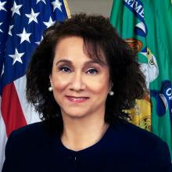 | Marcia Sigal, Acting Director, CDFI Fund  Marcia Sigal currently serves as Acting Director of the CDFI Fund and is the Deputy Director for Policy and Programs for the CDFI Fund. In this role, she implements the CDFI Fund's strategic vision through the design and management of the CDFI Fund's assistance programs. She previously served as the Program Manager of the CDFI Fund’s Capital Magnet Fund and as Director of the Program Policy Division for the Office of Affordable Housing Programs in the U.S. Department of Housing and Urban Development. During her federal career, she led the development and administration of nearly $40 billion in federal community development programs. Ms. Sigal is a recognized expert in affordable housing and community development policy that has also served in senior policymaking roles with the Council of State Community Development Agencies and the National Association of Housing and Redevelopment Officials. In these roles, Ms. Sigal shaped national outcome measurement metrics for community development programs, designed and launched new community development and affordable housing policies and programs, and developed capacity building and technical assistance programs for non-profit organizations, as well as state and local governments. She is an experienced executive with a demonstrated history of achievement in community development finance and affordable housing, policy analysis, government relations and business development skills. She has a Master's Degree in City Planning from the Massachusetts Institute of Technology and attended Cornell University, where she studied community services and social work.
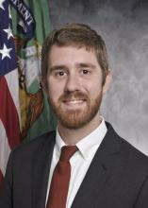 | Christopher Allison, Program Manager, New Markets Tax Credit Program  Christopher Allison is the Program Manager for the New Markets Tax Credit (NMTC) Program at the Community Development Financial Institutions Fund (CDFI Fund). Mr. Allison previously served as Associate Program Manager for the NMTC Program. He oversaw the development of NMTC application materials, led the implementation of the NMTC evaluation process in the CDFI Fund's new Awards Management Information System (AMIS), and made recommendations for tax credit allocations.  Prior to joining the CDFI Fund, Mr. Allison was a Program Manager at Single Stop USA, where he oversaw grant and performance management for a national portfolio of community-based organizations related to income supports. He worked on several innovative workforce development and asset building projects at Seedco, a national economic development intermediary. Mr. Allison has also held positions with Self-Help Ventures Fund and the Center for Community Capital in North Carolina.  Mr. Allison holds a Master of City and Regional Planning from the University of North Carolina at Chapel Hill with an emphasis on economic development, and a Bachelor of Arts degree in urban studies from Eugene Lang College at The New School in New York.
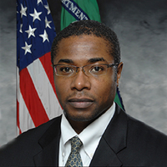 | Trefor Henry, Associate Program Manager, Office of Compliance Monitoring and Evaluation  Trefor Henry is an associate program manager in Office of Compliance Monitoring & Evaluation at the Community Development Financial Institution (CDFI) Fund. In this role, he is responsible for compliance monitoring and evaluation of the New Markets Tax Credit program. Prior to joining the CDFI Fund in 2004, Mr. Henry was a financial analyst with the National Federation of Community Development Credit Unions (NFCDCU), a certified CDFI. In this capacity, he was responsible for underwriting, portfolio management and compliance monitoring for NFCDCUs Capitalization Program–an investment and grant portfolio comprised of more than 125 community development credit union borrowers. Mr. Henry earned a master’s degree with a concentration in finance and marketing from New York University Leonard N. Stern School of Business and a bachelor’s degree in economics from Wesleyan University.
Oscar Gonzales, Associate Program Manager, Office of Financial Strategy and Research
Oscar Gonzales is a researcher and associate manager for the U.S. Department of the Treasury’s Community Development Financial Institutions Fund (CDFI Fund). Mr. Gonzales is associate manager for the CDFI Fund’s Office of Financial Strategy and Research. His research focuses on the evaluation and performance of the CDFI Fund’s national award and tax credit programs. Previously, he worked for the United States Congress at the U.S. Congressional Research Service (CRS) in the area of federal economic and community development programs, providing policy research support for members of Congress and Congressional Committees. His policy portfolio at CRS included federal programs such as the CDFI Fund, the U.S. Small Business Administration, the Economic Development Administration at the U.S. Department of Commerce, and the Community Development Block Grant program at the U.S. Department of Housing and Urban Development. Prior to working at CRS, he worked in the Division of Insurance and Research at the Federal Deposit Insurance Corporation, analyzing the financial performance of community banks and conducting research on the impact of national disasters on financial institutions and local communities. He is completing his PhD at the University of Maryland.

Jose Villalobos - For over three decades, José Villalobos has served as the Senior Vice President of government affairs/business development for TELACU, the largest Community Development Corporation (CDC). For over 50 years, TELACU has been rebuilding and enhancing underserved communities by providing valuable products and services—including the creation of new jobs, responsive financial institutions, business expansion, quality affordable housing, and educational opportunities for young people, families and veterans. As a result of these efforts, TELACU has developed $1 billion of real estate projects representing 4 million square feet of commercial space and over 3,600 housing units, which have created in excess of 16,000 jobs. TELACU has also successfully lent in excess of $2.5 billion in low-income communities throughout the state of California.

Villalobos is responsible for identifying, analyzing and accessing government programs/legislation at the federal, state and local levels that address the needs of underserved communities and can be utilized in the expansion of the company’s operating subsidiaries and acquisition/start-up of new business enterprises. Federal agencies include but are not limited to: Department of Treasury; HUD; HHS/Office of Community Services; Economic Development Administration and Minority Business Department Agency (MBDA); and SBA. He has successfully identified and accessed in excess of $450 million in public sector funds over the past fifteen years, including $365 million in New Markets Tax Credit (NMTC) Allocations from the US Department of Treasury/CDFI Fund. As part of managing TELACU’s NMTC Program, Villalobos also serves on the board of the New Markets Tax Credit Coalition. He also serves on the New Markets Tax Credit Advisory Boards of Chase Bank and Greenline Ventures.

In addition, Villalobos was instrumental in leading TELACU’s efforts in working with SBA to promulgate and issue the regulations allowing CDCs to participate in the 8(a) and HUBZone Programs.

Further, Villalobos is also responsible for the oversight and management of TELACU’s faith-based initiative, which seeks to partner with and strengthen the capacity of local faith-based and community organizations serving low-income communities.

Prior to joining TELACU, Villalobos worked with several private sector firms including Prudential-Bache Securities and Mattel, Inc. in the area of finance.

Mr. Villalobos is chair and president of Eastcoast Development Corporation, a Washington, D.C. based real estate firm. Villalobos has also served on the boards of UCLA Alumni Association and the National Association of Latino Community Asset Builders (NALCAB).

Mr. Villalobos received his Master of Business Administration degree from the Anderson School of Management, University of California, Los Angeles, and his Bachelors in Economics from the University of California, Los Angeles.
INVESTOR ROUNDTABLE
Charles Edelen - Charles Edelen is an assurance partner in CohnReznick’s tax credit advisory practice and has dedicated his career to serving clients in the community development space. Since 2006, his primary focus has been on advising clients in the New Markets Tax Credit industry.

Chuck has extensive experience providing assurance and compliance services to Community Development Entities (CDEs), developers, tax credit investors, and Qualified Active Low-Income Community Businesses. He assists clients throughout the entire life cycle of a New Markets Tax Credit transaction, helping them navigate the many programmatic requirements of both the IRS and the U.S. Treasury’s CDFI Fund.

In addition to developing the skills and knowledge of a dedicated practice group in the Mid-Atlantic region, Chuck conducts external trainings on a variety of community development related topics ranging from basic deal structures and flow of funds to current legislative updates and best practices for maintaining compliance with evolving U.S. Treasury and IRS regulations.

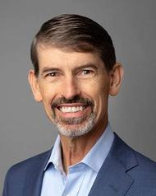 | Mike Novogradac – Michael Novogradac is the managing partner of Novogradac, which has been in business since 1989. He specializes in affordable housing, community development, historic preservation and renewable energy. Mr. Novogradac’s focus is in real estate taxation and accounting. He is the author of numerous real estate-related tax and accounting articles and books, including the Novogradac Opportunity Zones Handbook, the New Markets Tax Credit Handbook and the Low-Income Housing Tax Credit Handbook.  A frequent speaker at tax incentive conferences and forums throughout the country, Mr. Novogradac also broadcasts a weekly podcast, Tax Credit Tuesday. As a leading industry expert, he is frequently quoted in national media, such as The Wall Street Journal, The New York Times, Politico, Bloomberg, Forbes, CNBC News, NBC News, National Public Radio and Crain’s New York Business.  Mr. Novogradac is active in advocating for the inclusion of affordable housing, historic preservation, community development and renewable energy incentives in federal and state tax policy, and serves as advisor on industry and governmental affairs for the NMTC Working Group, LIHTC Working Group and the Opportunity Zones Working Group.  Mr. Novogradac provides input to the U.S. Department of the Treasury, Internal Revenue Service, Community Development Financial Institutions Fund, and other federal and state agencies as well as members of Congress, including testimony before the United States House Committee on Ways and Means. Mr. Novogradac also serves on the executive committee of the Housing Advisory Group and the boards of directors of the Affordable Housing Tax Credit Coalition, the National Housing Conference, the NMTC Coalition and Historic Tax Credit Coalition.  In 2016, Mr. Novogradac was inducted into the Affordable Housing Hall of Fame. He also received The Affordable Housing Visionary Award from The NHP Foundation in 2018, in recognition of his contributions to the affordable housing community and in 2020 was honored as one of the top 25 OZ Influencers through Opportunity Zone Magazine. Mr. Novogradac graduated from the University of California, Los Angeles, with a bachelor’s degree in economics. He received an MBA from the University of California, Berkeley. He is licensed in California, Oregon, Maryland and Texas as a certified public accountant. You can follow Mr. Novogradac on twitter @novogradac and on his blog at www.novoco.com/blog or listen to his weekly podcast at www.novoco.com/podcast.
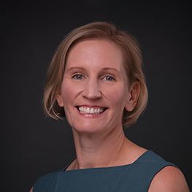 | Laura Vowell – Laura Vowell is the Managing Director of Community Finance Solutions at U.S. Bancorp Impact Finance. Her team invests in New Markets and Historic Tax Credits and lends to CDFIs and other intermediaries. Since joining USBIF in 2005, Vowell has been instrumental in investing billions of dollars of tax credit equity into projects around the country. Previously, she managed the national team of NMTC and HTC originators who secure funding for a diverse array of projects, from food banks and performing arts centers, to grocery stores and historic hotels.  Vowell is a vocal advocate for Racial Equity within the New Market Tax Credit industry and is a regular speaker at national community development and historic preservation industry conferences and tax credit-related events. She is a Founder of Women in Tax Credits, the Board Member of the NMTC Coalition, and on the Executive Committee of the Partnership for Job Creation. She is currently a member of the St. Louis Symphony’s Community Advisory Committee and Equity, Diversity and Inclusion Task Force.  Vowell began her career in the Washington D.C. area as a transportation engineer. Prior to joining USBIF, she worked with a private real estate developer, managing several redevelopment projects in the Los Angeles area. She holds an M.B.A. from the Anderson School of Business at UCLA and a B.S. in Civil Engineering from Rensselaer Polytechnic Institute in Troy, New York.
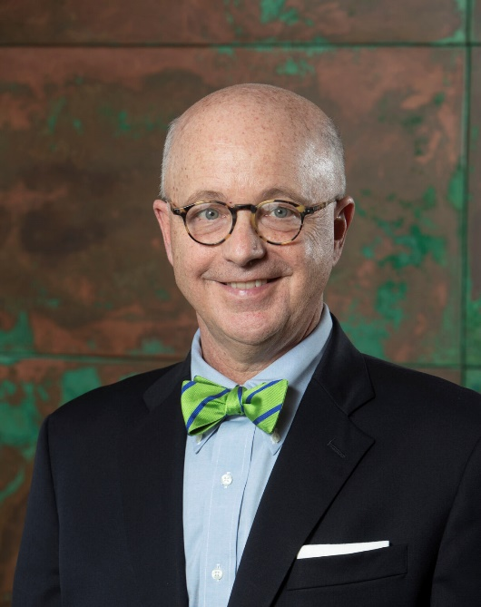 | Jim Howard – James D. Howard, Jr. is the President of Dudley Ventures. A native of The Bronx, New York. Mr. Howard earned his degree from The College of the Holy Cross in Worcester, Massachusetts and a law degree from Georgetown University Law Center. Dudley Ventures was founded by Mr. Howard in 1996 and has been one of the leading advocates of the NMTC Program since its inception.  Dudley Ventures, with its 25+ member team, successfully manages NMTC investment funds in excess of $1.6B, providing all origination, fund reporting and compliance activities in-house. In addition, DV’s CDE, DV Community Investment, has been awarded $525,000,000 of NMTC allocation to date. Acquired by Valley National Bancorp in October 2021, DV now has the resources of a $50B+ publicly traded financial institution.  Mr. Howard is a Board Member of the New Markets Tax Credit Coalition and has been an innovator in the NMTC industry. Mr. Howard has authored numerous articles on tax credit investing and is a regular speaker at major New Markets Tax Credit conferences. Mr. Howard is a licensed member of the Arizona State Bar and holds the FINRA designation of Principal and Investment Banker.
 | Chimeka Gladney – Chimeka Gladney is a Senior Vice President for Truist Community Capital responsible for sourcing and closing NMTC investments for the Mid-Atlantic. Ms. Gladney has nearly 20 years of finance, community development economic development experience, including public finance, tax credit finance, and public-private partnerships. Prior to joining Truist, Ms. Gladney managed the NMTC program for Enterprise Community Partners, whose NMTCs allocations totaled over $1.0B. She also served as the Director of Project Management at US Bank CDC for NMTC and HTC equity investments. Ms. Gladney has a BBA in Finance from Howard University and an MBA from Stanford University. Ms. Gladney has served on the Advisory Board for numerous CDEs including Dudley Ventures, Urban Research Partnership and Community Hospitality Healthcare Services.
LUNCH KEYNOTE
 | En Jung Kim - En Jung Kim is executive director of Chase community development group where she is primarily responsible for managing the originations team for new markets tax credit (NMTC) investments nationally. Prior to joining the firm, Ms. Kim was acquisition manager at National Equity Fund Inc., where she supported the placement and management of NMTC activities of the Local Initiatives Support Corporation (LISC) since 2004. Established in 1979 by the Ford Foundation, LISC is a national nonprofit organization that provides grants and loans to support community development in low-income communities. Previously, she worked as an associate in the global technology group at the Investment Banking Division of Lehman Brothers where she performed valuation and financial analyses and participated in the execution of various types of transactions, including equity offerings and mergers and acquisitions. Additionally, she worked in Seoul, Korea, in the global financial services group at Lehman Brothers. Ms. Kim has bachelor’s degrees in international relations and economics from the Wharton School of Business at the University of Pennsylvania.
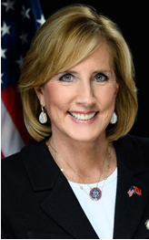 | Representative Claudia Tenney
LEG PANEL
Stephen Simonetti, Senior Advisor, Office of Representative Claudia Tenney
Stephen Simonetti serves as senior advisor to Representative Claudia Tenney (NY-24), where he manages a portfolio containing tax, trade, oversight, social security, and welfare. Prior to that, he served in the office of Representative Jackie Walorski (IN-02) for nearly eight years in a number of different capacities, mainly focusing on her tax, trade, and oversight priorities. He also managed her reelection campaign in 2018. Before coming to the Hill, he worked in the government relations office for The Boeing Company. Stephen attended college at Indiana University in Bloomington, Indiana and graduated with majors in Russian language, Spanish language, and political science. He is an avid soccer fan and enjoys watching the English Premier League in his spare time.

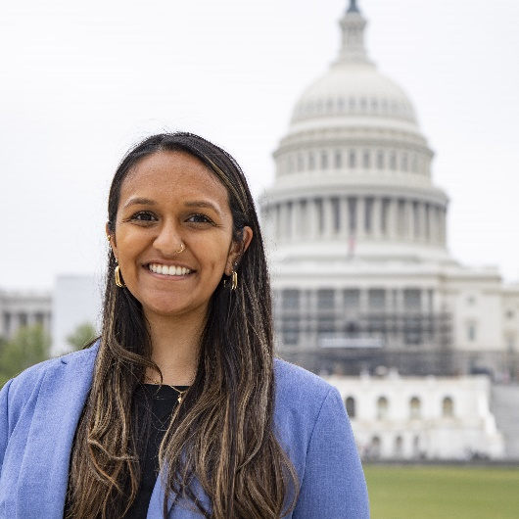 | Shivani Pampati, Tax and Economic Policy Adviser, Senate Small Business and Entrepreneurship for Senator Ben Cardin  Shivani Pampati is Senator Cardin’s Tax and Economic Policy Advisor, covering his Senate Finance Committee portfolio, including tax, retirement, banking, and trade. Through this role she has helped carry forward legislation like SECURE 2.0, and leads the Senator’s work on tax legislation like the New Markets Tax Credit Permanency Act. Shivani also serves on the Senate Small Business Committee side where Senator Cardin is the Chair, leading the diversity, equity, and inclusion portfolio. Prior to this role, Shivani was a Legislative Correspondent for Senator Chris Coons of Delaware and began her career in Congress by working for Speaker of the House Nancy Pelosi in 2019. Before coming to D.C., Shivani was the Policy and Research Director for then 2018 U.S. House Candidate Amy McGrath, who was running in her home state of Kentucky. Shivani graduated from Stanford University in 2018 with a B.A. in Public Policy.
Kathryn Chakmak, Legislative Assistant, House Ways and Means Committee (Majority) and Office of Representative Jason Smith
Kathryn Chakmak is the Tax Policy Advisor for Ways and Means Chairman Jason Smith (R-MO). In her role, she handles a diverse domestic tax policy portfolio. Before transitioning to the Ways and Means Committee, Kathryn served as a Legislative Assistant for Congressman Smith. In her roles, she served as the primary advisor for a legislative portfolio that included domestic, international, and corporate tax, financial services, pensions, education, small business, and housing. Prior to joining Team Smith, she served as the Special Assistant to the Staff Director at the House Ways and Means Committee. She is originally from Las Vegas, Nevada and received her Bachelor’s in Economics and Government from Claremont McKenna College in southern California.

Grace Enda, Tax Policy Analyst, Senate Finance Committee (Majority)
Grace Enda currently serves as a Tax Policy Analyst for the Senate Finance Committee, where she has served under Chair Wyden since 2021. She advised on the Inflation Reduction Act. Prior to joining the Committee, Grace was a Senior Research Assistant at the Urban-Brookings Tax Policy Center. Grace received a Bachelor of Arts in Government and Economics from the University of Texas at Austin.
CONGRESSIONAL BRIEFING
Paul Anderson - Paul Anderson works to advance the legislative priorities of community and economic development clients by lobbying Congress and federal agencies on their behalf. Collecting and analyzing data and case studies, Paul also creates policy tools, including comprehensive reports used in the firm's lobbying and advocacy efforts.

Previously he served as Director of Programs at the George Mason University Center for Social Entrepreneurship, and in Congressional Affairs at the National Trust for Historic Preservation.

Paul is a graduate of the University of Virginia with a degree in Political Science.

Alexander Justice Moore – Alex came to DC Central Kitchen in 2006 as an undergraduate grant writing intern from Ithaca College. He returned to the organization in 2010 after earning a master’s degree from Georgetown University, and became Chief Development Officer in 2014. That same year, he published his first book, “The Food Fighters: DC Central Kitchen’s First Twenty-Five Years on the Front Lines of Hunger and Poverty.” In 2022, Alex was named one of Washington Business Journal’s 40 Under 40 in recognition of his work with DC Central Kitchen and our Bringing the Kitchen Home comprehensive campaign.

Named one of Elevation DC’s “Fifty under fifty DC food heroes” in 2015, Alex was appointed by Mayor Muriel Bowser to the inaugural DC Food Policy Council in 2016 and was featured by the Smithsonian Institution’s Anacostia Community Museum as one of 12 local changemakers in its 2021 ‘Food for the People’ exhibition. Alex has been a featured speaker at dozens of colleges, universities, and major events, including South by Southwest Interactive, the Chesapeake Food Summit, and the Universities Fighting World Hunger Global Summit.

Alex and his wife Kathryn do their best to keep up with their three young children, none of whom find this paragraph very interesting.

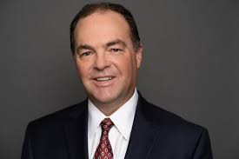 | Sam Walls – Sam Walls, III has been with Arkansas Capital Corporation and Heartland Renaissance Fund for over 20 years and was named CEO January 2022. A 1996 graduate of Bowen Law School in Little Rock, Arkansas, Mr. Walls has helped Arkansas Capital Corporation deploy almost $2 billion in capital through small business lending and project finance.  Arkansas Capital Corporation was formed in 1957 and is a Community Development Financial Institution (CDFI).  Arkansas Capital is one of the oldest economic development entities in the state of Arkansas and now serves not only Arkansas but Texas, Oklahoma, Missouri, Tennessee, Mississippi and Louisiana. Arkansas Capital makes conventional as well as government guaranteed loans to small businesses that struggle to access capital from traditional sources and provides project finance capital through venture capital, Federal and State New Market Tax Credits and EB-5 capital. Arkansas Capital also promotes entrepreneurial education.
Kermit Billups – Kermit Billups is an Executive President of Greenline, and is involved in activities including transaction structuring, tax credit syndication, debt financing, origination, underwriting, and NMTC compliance.

Kermit began his career at Capmark in 1999 and has been a member of the NMTC platform since 2004. He has been in investment banking since 1992, with an emphasis on developing solutions for deficiencies in low-income communities nationwide, including complex and innovative financings to benefit low-income housing tax credit and New Markets Tax Credit transactions. He has participated in over $3.5 billion of project finance and affordable housing capital. He has successfully completed over 50 taxable and tax-exempt revenue bond programs to serve low and moderate-income individuals. Prior to joining Capmark, Kermit worked for Honeywell, IBM, Legg Mason, and Stephens Inc.

Kermit has a B.A. in Economics from Harvard College and an M.B.A. from the Harvard Graduate School of Business Administration.

