July 17, 2017

The Honorable Orrin Hatch
Chairman
Committee on Finance
US Senate
219 Dirksen Senate Office Building
Washington, DC 20510

RE: Call for Feedback on Tax Reform
Dear Mr. Chairman:
The New Markets Tax Credit (NMTC) Coalition is pleased to respond to your call for comments on comprehensive tax reform and to indicate strong support for the NMTC, which provides private investors with a modest federal tax credit for investments made in businesses or economic development projects located in some of the most distressed communities in the nation.
The NMTC Coalition is a national membership organization that advocates on behalf of the NMTC program. More than 150 investors and community development practitioners belong to the Coalition, which is managed by Rapoza Associates, a public interest government relations firm located in Washington, DC.
In order to strengthen businesses, growth, and job creation, the NMTC Coalition recommends the following:
- An indefinite extension of the New Markets Tax Credit (NMTC);
- An increase in the annual NMTC allocation and indexation of the allocation to inflation in future years; and
- An exemption from the Alternative Minimum Tax (AMT) for NMTC investments thereby ensuring NMTC investors the same consideration under the AMT as is currently provided to investors in many other federal tax credits.
All these provisions are included in S. 384, The New Markets Tax Credit Extension Act, introduced in the 115th Congress by Senators Blunt (R-MO) and Cardin (D-MD).
The following paper includes history, research, and data on the NMTC’s impact in low-income communities across the country.
Sincerely,
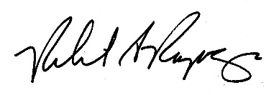
Robert A. Rapoza

Legislative History and Origins
The NMTC was originally authorized as part of a bipartisan effort to jumpstart investment and economic growth in low-income urban neighborhoods and rural communities. These areas have experienced a long-term decline, and most have not recovered from the Great Recession. These forgotten farming towns, urban neighborhoods, and post-industrial suburbs lack access to the patient capital needed to support and grow businesses, create jobs, and sustain healthy local economies.
The roots of the NMTC can arguably be traced back to Jack Kemp. As HUD Secretary and Congressman, Kemp was a longtime advocate of employing the tax code – rather than government grants – as a market driven approach to incentivize private sector investment in low-income communities. Beginning with the Tax Reform Act of 1986 (P.L. 99-514), Congress increasingly followed Kemp’s lead. The 1986 Act established the Low Income Housing Tax Credit (LIHTC), which is now the nation’s largest financier of affordable housing. The Omnibus Reconciliation Act of 1993 (P.L. 103-66) permanently codified the LIHTC and also created Renewal Communities, Empowerment Zones and Enterprise Communities, programs with defined geographies for revitalization. These programs not only served to assist individuals and families obtain affordable housing and build and grow small businesses, they helped provide investments in communities that revitalize local economies.
Building on the success of that model, but recognizing the bluntness of the Zone approach, Congress enacted the Community Renewal Tax Relief Act of 2000. The bipartisan legislation included $25 billion in new authorities, including the creation of the New Markets Tax Credit. It authorized $15 billion in NMTC credit authority stretching from 2001 to 2007.
The Community Renewal Tax Relief Act drew support from across the political spectrum including prominent Republican Members of Congress such as Senator Olympia Snowe (ME), Sen. Rick Santorum (PA), Rep. JC Watts (OK), and then Rep. James Talent (MO). This tradition of bipartisan support for the New Markets Tax Credit continues to this day.
Since that time, Congress has extended the NMTC several times:
- An additional $1 billion was authorized for communities hard-hit by Gulf Coast hurricanes, Gulf Opportunity Zone Act of 2005 (P.L. 109-135);
- In 2006, Congress extended the NMTC for 2008 at $3.5 billion in annual credit authority through the Tax Relief and Health Care Act of 2006 (P.L. 109-432);
- The Emergency Economic Stabilization Act of 2008 (P.L. 110-343) extended the Credit for 2009, again at $3.5 billion in annual credit authority;
- The American Recovery and Reinvestment Act of 2009 (P.L. 111-16), increased credit authority to $5 billion for both 2008 and 2009;
- The Tax Relief, Unemployment Insurance Reauthorization and Job Creation Act of 2010 (P.L. 111-312) provided a two-year extension of the NMTC (2010 and 2011) with annual credit authority of $3.5 billion;
- The American Taxpayer Relief Act of 2012 (P.L. 112–240) provided a two-year extension of the NMTC (2012 and 2013) with annual credit authority of $3.5 billion;
- The Tax Increase Prevention Act of 2014 (P.L. 113-295) extended the NMTC for 2014 at $3.5 billion in annual credit authority; and
- Most recently, the PATH Act (P.L. 114-113) extended the NMTC for five years, from 2015 to 2019, at $3.5 billion in annual credit authority. The PATH Act was the longest authorization for the NMTC since the Community Renewal Tax Relief Act and, at $17.5 billion, the largest in the history of the Credit.
The Community Development Financial Institutions (CDFI) Fund, which administers the NMTC, awarded $7 billion in NMTC allocations, combining the 2015 and 2016 rounds. Based on NMTC Coalition analysis of more than 4,000 previous NMTC projects, the $7 billion in allocation will finance 844 businesses and revitalization projects and create around 166,000 jobs in 2017. The $7 billion in NMTC allocation costs the federal government only $1.88 billion in foregone tax revenue, and thanks to the NMTC’s public-private partnership model, low-income communities will receive $14 billion in total capital, including $2.8 billion to rural areas.

How it Works
The NMTC program provides private investors with a modest federal tax credit for investments made in businesses or economic development projects located in some of the most distressed communities in the nation – census tracts where the individual poverty rate is at least 20 percent or where median family income does not exceed 80 percent of the area’s median income.
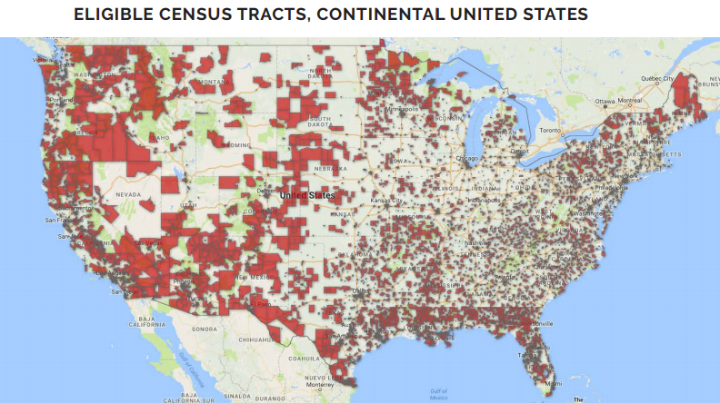
Three main players participate in the NMTC program: investors, community development entities, and businesses in eligible communities.

COMMUNITY DEVELOPMENT ENTITIES  In order to deliver capital to underserved “new markets,” the NMTC authorizing statute created a new category of investment intermediary, Community Development Entities (CDEs). A CDE must be a domestic corporation, have a demonstrated mission of serving or providing capital to low-income communities or people, and maintain accountability to residents of low-income communities through representation on a governing or advisory board to the CDE. Most CDEs are affiliates of mission-driven organizations like Community Development Financial Institutions, for-profit entities, government entities, or private financial institutions. CDEs put together a business plan to finance high impact businesses and revitalization projects in low-income areas  and apply for allocation to the CDFI Fund.  Throughout the history of the NMTC, demand for allocation has exceeded the authorized amount by nearly eight to one. CDEs requested $319 billion in allocation authority between 2003 and 2016 while the CDFI Fund made $50.6 billion in allocation available. The historic success rate of applications for credits is less than 25 percent. | QUALIFIED EQUITY INVESTMENTS  Private investors make Qualified Equity Investments (QEIs) into CDEs. CDEs take the proceeds and invest them in businesses and revitalization projects in low-income communities. Investors (typically regulated financial institutions) receive a federal tax credit of 39 percent taken over seven years (five percent years one through four and six percent years five through seven). Because the investment is taxable and is taken over seven years, the net cost to the federal government of each dollar of NMTC allocation is about 26 cents per the Joint Committee on Taxation.  QUALIFIED ACTIVE LOW-INCOME COMMUNITY BUSINESS (QALICB)  QALICBs are the end beneficiaries of the NMTC who receive gap-financing to expand their business, build a new school, or stay competitive. To qualify as a QALICB, a business must be located in a low-income community, in addition to conducting business and deriving at least 50 percent of its income in a low-income community. Examples of QALICBs are a health clinic, a steel fabrication plant, a developer of real estate, and a homeless shelter.

Oversight & Ineligible Uses
The CDFI Fund monitors compliance once credits are awarded and the Internal Revenue Service (IRS) issues guidance on NMTC investments and monitors taxpayer compliance. Allocatees must provide the CDFI Fund with nearly 200 data points on each NMTC transaction, including data on the location of loans and investments, jobs created and other community impact metrics, interest rates and financial products, and more.
The NMTC is a very flexible incentive. It can finance a variety of projects, from broadband in remote Alaska to a YMCA in downtown Los Angeles. But not all businesses are eligible. CDEs cannot finance: commercial golf courses; country clubs; massage parlors; hot tub facilities; suntan facilities; racetrack or other facility used for gambling; or liquor stores. Certain agricultural activities are ineligible.
Even if a CDE finances eligible activities, if it cannot demonstrate tangible community benefits to its projects, it is unlikely to receive additional NMTC allocations.

But-For Test
CDEs employ a “but-for” test, limiting the amount of NMTC-generating financing necessary for financial feasibility. The NMTC typically provides “last-in” gap financing, meaning it is the last financing secured to make a project viable. CDEs and investors evaluate the sources and uses of available capital, the business plan of the enterprise in question, and its impact on the low-income community in order to determine how much NMTC financing is needed to complete the project and maximize community impact.
If additional subsidies are not needed, the project will not receive NMTC financing. The NMTC is a scarce resource, which CDEs deploy accordingly. CDEs have no incentive to provide more NMTC-backed financing than what is absolutely necessary to make a project viable. Only after all the financing from other sources is committed, and the impact is clear, does a CDE commit to provide NMTC financing.

Low Fees and Retentions
If NMTC loans were approved and underwritten by the federal government, there would be significant overhead costs. Instead, these duties are handled by the private sector. Under the law, CDEs are required to invest at least 85 percent of Qualified Equity Investments (QEIs) into projects. According to the GAO’s survey for 2011-2012, fees and retentions only totaled 7.1 percent of total NMTC Qualified Equity Investments (QEIs). The Urban Institute’s Evaluation of the NMTC indicated that CDEs invested 97 percent of QEIs into businesses and projects. In other words, the two most recent reports on NMTC indicate that fees and retentions are well below the requirements established in law and regulation.

The Need for Patient, Flexible Capital in Low-Income Communities
The basis for the NMTC is that businesses’ success depends on access to capital. There are attractive investment opportunities in low-income communities, but the cost and availability of capital in these ‘New Markets’ is an impediment to economic growth. Investors and firms often lack sufficient information to assess property value or consumer demand in low-income communities, where informal economies distort data. The capital gap in underserved markets impedes the construction or renovation of community facilities and revitalized industrial and commercial facilities that would create jobs, economic opportunity and improve the quality of life.
Fifteen years after the NMTC’s inception, the need for patient, flexible capital is as great as ever in low and moderate income rural, urban, and native areas underserved by commercial lenders and largely forgotten by policymakers in Washington, DC.
A 2011 study by the Initiative for a Competitive Inner City found that “firms in low-income census tracts received 21 percent fewer loans than would be expected, based on the number of firms in the tracts,” even with a healthy demand for capital and an untapped consumer base. As a result, inner city neighborhoods are under-retailed, forcing residents to leave their neighborhoods to shop.
Small towns and farming communities also continue to be underserved by conventional lenders. An analysis by the Federal Financial Institutions Examination Council found that while rural low-income census tracts include about 6 percent of the population and about 6 percent of the businesses, they only receive around 5 percent of small business loans. The decade’s long trend of community bank closure and consolidation has hit rural areas particularly hard. The number of community banks in the United States has declined by an average of 300 per year over the past 30 years, according to data from the Federal Deposit Insurance Corporation. Recent federal regulations have limited the ability of community banks to grow financing activities, and the NMTC can help fill the gaps created by these limitations.
The Office of the Controller of Currency found that residents of Indian Country face challenges securing commercial credit, including “limited access to brick-and-mortar offices of regulated financial institutions; the perception by tribal business enterprises, even those with adequate collateral and good credit histories, that commercial bank financing is difficult to secure; a lack of diversity in funding sources; a lack of equity resources, collateral, and credit history, resulting in commercial credit denials for Indian small business owners.”

Community Impact

Jobs and Return on Investment
The NMTC has a strong and proven track record in meeting the capital needs of low-income communities. Between 2003 and 2014, $38 billion in direct NMTC investments were made in businesses. In turn, these NMTC investments leveraged nearly $75 billion in total capital investment to businesses and revitalization projects in communities with high rates of poverty and unemployment. By law, all NMTC investments must be made in economically distressed communities. However, more than 72 percent of all NMTC investments have been in communities exhibiting severe economic distress, including unemployment rates more than 1.5 times the national average, a poverty rate of 30 percent or more, or a median income at or below 60 percent of the area median.
Between 2003 and 2012, the NMTC generated about 750,000 jobs, at a cost to the federal government of less than $20,000 per job. The New Markets Tax Credit generates economic activity, providing a return on investment to the federal government. In 2012, NMTC-financed businesses generated $984 million in federal tax revenue which more than covered the estimated $800 million cost of the Credit in terms of lost tax revenue in 2012. In addition, in 2012, NMTC investments nationwide generated $542 million in state and local tax revenue.

Amenities and Facilities
Beyond creating jobs and generating economic activity, the NMTC helps enhance community revitalization efforts by financing community facilities and other important quality of life amenities. Between 2003 and 2014, more than 1,400 NMTC projects involved community amenities like healthcare facilities, schools, nonprofit service providers, and childcare centers. A recent Urban Institute study examined the extent to which the NMTC helps communities add amenities, improve services, and finance community facilities. The study found that 88 percent of NMTC projects brought direct or indirect quality-of-life improvements to their communities, including parks, playgrounds, shopping centers, health clinics, and other amenities.

Project Types
From manufacturing business expansions to incubator space for entrepreneurs to new healthcare and childcare facilities, the program was designed as a flexible incentive for economic development that meets evolving community needs. Instead of Washington picking winners and losers, the New Markets Tax Credit empowers local decision-making on important economic development projects. The nonprofit and industry sectors receiving NMTC financing are diverse, reflecting a cross-section of the American economy.
About twenty percent of NMTC financing goes to manufacturing and industrial projects. The NMTC helps manufacturers grow a line of business, build a new facility, secure working capital, or purchase needed equipment. Nearly one-third of NMTC projects involve healthcare facilities, affordable space for innovative nonprofits and social enterprises, educational facilities, and other amenities that directly improve the quality of life. (See Chart below).

Recent NMTC projects include:
- NMTC financing totaling $17 million to construct a $90 million sawmill and lumber factory in Newton, MS;
- Historic renovation of a long-abandoned tobacco mill into a mixed-used facility featuring a biotech innovation space, offices, entertainment, and restaurant space bringing 500 quality jobs to Winston Salem, NC;
- Equipment financing to remediate and recover metals from an old auto scrapyard;
- A light manufacturing tech-incubator [where?] with a variety of tenants, including a robotics company.
- A timber and forestry operation in Oregon;
- A small loan helped an Indio, CA ice cream distributor purchase a new warehouse;
- A homeless shelter in Brooklyn, NY;
- A hospice care center in Abilene, TX;
- Four new community centers in Oklahoma Indian Country; and

The NMTC as Part of a Reformed Tax Code
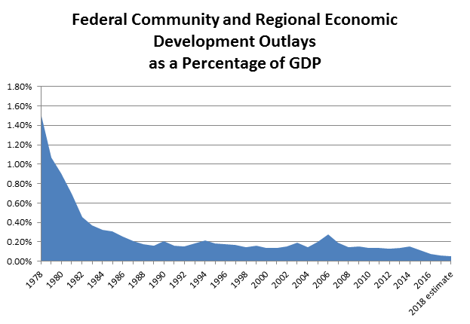
Unlike many scores of duplicative federal grant and loan programs, the NMTC is unique in its targeting and purpose. The NMTC is the only federal incentive that is primarily intended to drive capital to credit-starved businesses in economically distressed urban and rural communities, accounting for about 8 percent of annual tax expenditures for community development. Unlike other programs that address a policy concern (such as affordable housing) that may overlap with low-income communities, the NMTC provides both (1) the flexibility to finance a variety of businesses and projects in these low-income communities along with (2) an effective established system to deliver that financing.
Because of reductions in federal spending, tax expenditures for community development are an increasingly important element in the federal support for housing as well as economic and community development. According to data from OMB, as measured as percentage of GDP, federal spending for community development – HUD, Agriculture, Commerce, and Interior -- has fallen by 75 percent since 1980.
Private investor interest in the NMTC is at an all-time high. Increased competition has led to increased pricing which in turn provides more capital into low-income communities. The following factors motivate investors:
- Compliance with the Community Revitalization Act (CRA). Most NMTC investors are private financial institutions and receive credit for investing in low-income census tracts, as defined by CRA;
- A low risk, low return investment. NMTC investors typically receive an annual return from the tax credit of between 3 and 5 percent over 7 years;
- A commercial interest in moving into new communities that are eligible under NMTC;
- Supporting existing customers and bolstering an underperforming market in the bank’s footprint; and
- Corporate Social Responsibility priorities.
In a 2017 survey, CDES and NMTC investors reported substantial demand for credits, including the $7 billion allocated in November of 2016. Investors associated with the New Markets Tax Credit Coalition Investor Advisory Committee do not anticipate a reduction in the demand for credits and expect that certain elements of tax reform – most specifically elimination of the Alternative Minimum Tax (AMT) – may bring in new investors interested in investing in NMTC.
NMTC attracts private capital that would not otherwise go to low-income communities or would come at too high a risk and cost. There is ample evidence that the NMTC market is robust and pricing is stable. While tax reform has many moving parts, if the final product is similar to the House Blueprint from June 2016, a lower top corporate tax rate, in of itself, would not adversely affect NMTC equity pricing, and may even be modestly beneficial.

Opportunities for Increased Efficiency
To sustain or even increase pricing and efficiency, Congress could take steps to broaden the NMTC investor base would increase competition and efficiency. Better pricing of NMTCs would drive even more capital to businesses operating in NMTC-qualified communities.
Over the years, Congress has made improvements to the Low Income Housing Tax Credit (LIHTC) that increased efficiency and enhanced the government’s investment, and these changes may also help sustain and improve NMTC pricing.
In 1993, seven years after establishing LIHTC, Congress made it a permanent part of the Internal Revenue Code. The result: with greater investor certainty, demand spiked and pricing for housing credits went up.
In addition, Congress provided an AMT exemption to LIHTC investors through the Housing and Economic Recovery Act of 2008. This change - along with the economic recovery – eventually strengthened LIHTC prices. Pricing increased from about 65 cents in early 2010 to almost 94 cents by the end of 2014.
NMTC investments are not exempt from the Alternative Minimum Tax (AMT). Exemption from the AMT, should it survive tax reform in some form, would diversify the pool of investors who could invest in the NMTC, opening up the NMTC investor market to new investors, including community banks and corporate investors that are currently restrained by AMT. Moreover, making the NMTC permanent would also improve pricing, increase investor diversity, and relieve the uncertainty created by last minute annual extensions of the Credit.

Conclusion
It is time to make the New Markets Tax Credit permanent law, assisting more economically distressed rural and urban communities in jump-starting their economies and promoting revitalization. The NMTC meets an important and critical need for private-sector investment in economically distressed urban and rural communities. It blends the market incentive of Jack Kemp’s Enterprise Zones with a flexible community-driven approach. Furthermore, data on the impact of the NMTC shows that it has not only achieved its purpose, but it has done so at a relatively low cost to the federal government, particularly when compared to traditional economic development grant programs. Perhaps most importantly, these investments catalyze additional investments to the community, creating a ripple effect of economic development in some of the poorest and hardest hit areas in America. With dwindling government resources, the priority should be given to programs that achieve their purpose efficiently, and the NMTC hits the mark.

July, 2017

GAO-14-500: Published: Jul 10, 2014.
Urban Institute Evaluation of the NMTC: June 2013.
Commercial Lending in Indian Country: Potential Opportunities in a Growing Market”, the Office of the Controller of Currency, February 2016
CDFI Fund’s FY 2015 Agency Financial Report
NMTC Coalition Estimate
A Decade of the NMTC (2003-2012), NMTC Coalition (December 2014).
The NMTC cost the federal government about $1 billion in forgone revenue in 2014. In total, tax expenditures for community development amounted to $12.035 billion.
OMB Historical Tables.
According to data from Novogradac & Company.

